An Investigation of Slope-Intercept Form
Goal
The students will investigate slope-intercept form using hands-on materials.

Objective
Students will explain slope as a rate of change between dependent and independent variables. Students will determine the slope of a line, given the coordinates of two points on the line.
Materials
-Plastic Bag
-Rubber Band
-Washers
-Pencil
-Tape
-Ruler (centimeter)
-Calculator
-Worksheet

Procedure
Step 1:
Cut a small hole in a top corner of a plastic sandwich bag. Loop a long rubber band through the hole.
Step 2:
Tape the free end of the rubber band to the desktop.
Step 3:
Use a centimeter ruler to measure the distance from the desktop to the end of the bag. Record this distance for 0 washers in the bag using the table below.
Step 4:
Place one washer in the plastic bag. Then measure and record the new distance from the desktop to the end of the bag.
Step 5:
Repeat the experiment, adding different numbers of washers to the bag. Each time, record the number of washers and the distance (in centimeters!) from the desktop to the end of the bag.

Number of Washers | Distance
X | Y
0
1
2
3
4
5
6
7
8

Analyze the Data
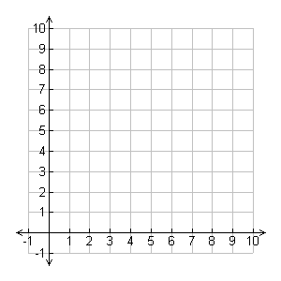
- The domain contains values represented by the independent variable, washers. The range contains values represented by the dependent variable, distance. On the grid paper included, graph the ordered pairs (washers, distance).

Distance (Centimeters)

Number of Washers

- Write a sentence that describes the points on the graph.
____________________________________________________________________
____________________________________________________________________.
- Describe the point that represents the trial with no washers in the bag.
____________________________________________________________________
____________________________________________________________________.
- The rate of change can be found by using the formula for slope.
Rise = _______change in distance______
Run change in number of washers
*Find the rate of change in the distance from the desktop to the end of the bag as more washers are added.
____________________________________________________________________
____________________________________________________________________.
- Explain how the rate of change is shown on the graph.
_____________________________________________________________________
_____________________________________________________________________.

An Extension
Draw a graph for each situation.
- A bag that hangs 10.5 centimeters from the desktop when empty and lengthens at the rate of the sample.

- A bag that has the same length when empty as the sample and lengthens at a faster rate.

- A bag that has the same length when empty as the sample and lengthens at a slower rate.

